Simple wrist warmers without fingers in rack crochet pattern
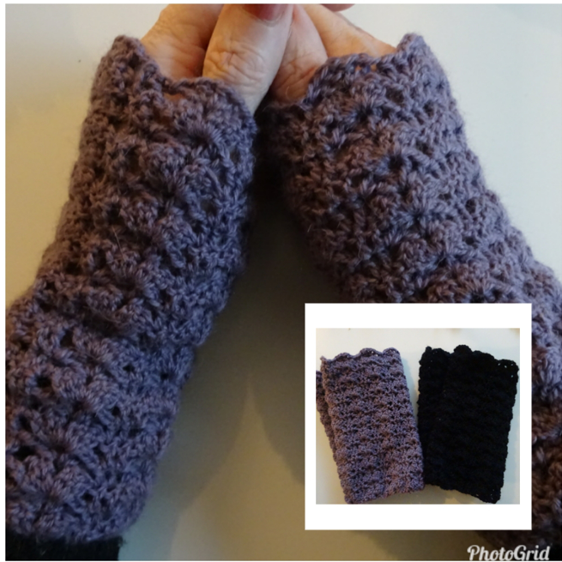

Stitches used in this pattern (UK term):
Tr - treble crochet
Ch - chain stitch
Sl st - slip stitich
Here is the pattern (multiple 7 sts):
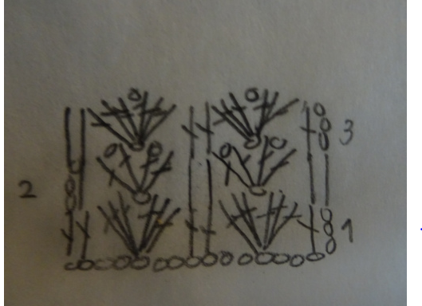

Ch 49
Step 1: 1 tr in 4th ch form hook, miss 2ch (3tr, ch1, 3tr) in the next ch, * miss 2ch, 1 tr in each of next 2ch. Miss 2ch (3tr, ch1, 3tr) in the next ch. Rep from * 5 times more. 1 sl st in into the start. 1 sl st into next tr. It is now a ring, turn.
It is now 7 rack (3tr, ch1, 3tr) with 2 tr between.
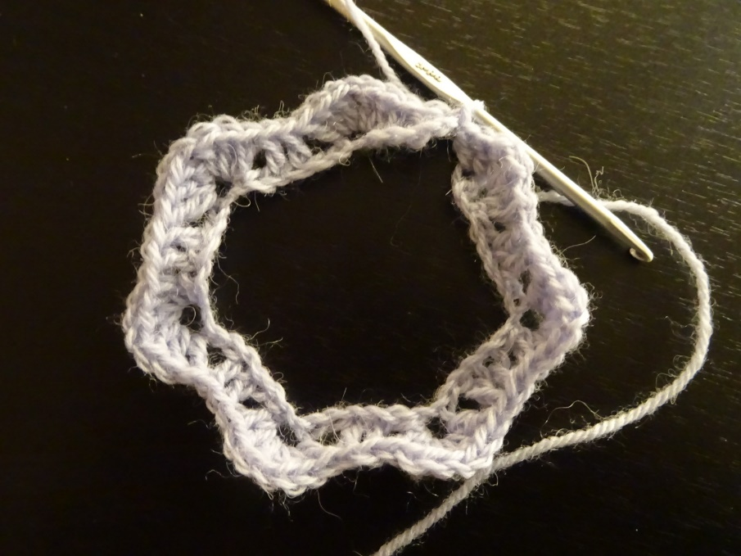
Step 2: Ch3 miss the first tr, 1tr in the next tr. Miss 3tr (1tr, ch1, 1tr, ch1, 1tr, ch1, 1tr) in the next ch sp. * Miss 3 tr, 1 tr in each of next 2 tr. Miss 3tr (1tr, ch1, 1tr, ch1, 1tr, ch1, 1tr) in the next ch sp. Rep from * 5 times more. 1 sl st in into the start. 1 sl st into next tr, turn
It is now 7 rack (1tr, ch1, 1tr, ch1, 1tr, ch1, 1tr)) with 2 tr between.
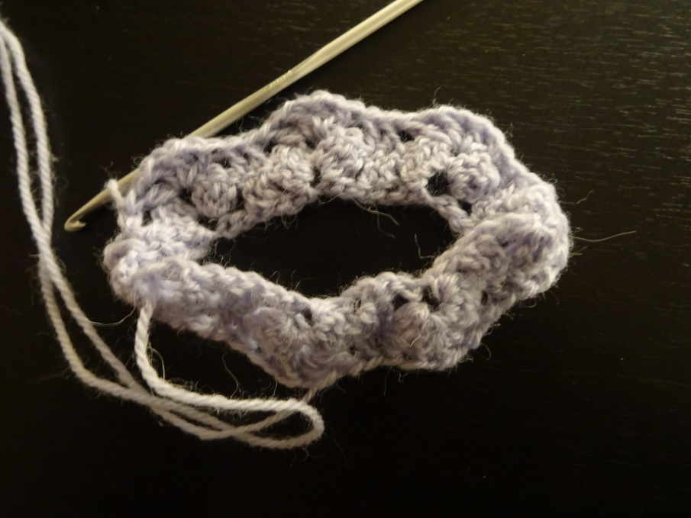

Step 3: Ch3, miss first tr, 1 tr in next tr. Miss 1 tr, ch1, 1tr (3tr, ch1, 3tr) in the next ch, * miss 1 tr, ch1, 1 tr in each of next 2tr. Miss 1tr, ch1, 1tr (3tr, ch1, 3tr) in the next ch * Rep from * 5 times more. 1 sl st in into the start. 1 sl st into next tr.

It is now 7 rack (3tr, ch1, 3tr) with 2 tr between.
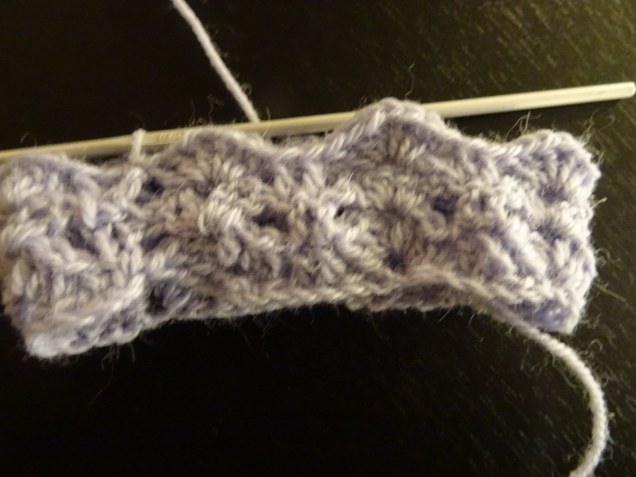
Repet Step 2 ten times and Step 3 nine times.
Crochet the right and left the same way.
Mounting: There is no mounting, only fastening of two threads and the wrist warmers is finished.

